205 Project report by Chau Cheuk Man Calvin

Cover Page

Student ID: 5520 1937

GitHub link: <https://github.com/chaucheukmancalvin/calvin>

YouTube link: <https://youtu.be/L1lJcP8GAkw>

1. For this term I learnt about html , CSS, Java script, python-flask, bootstrap,

jQuery.

In html I have learnt about the usage of tags and the formats in HTML5.

In CSS I have learnt setting the style for html.

In Java script I have learnt change content or style in html by DOM..

In Python I have learnt use flask to connect localhost.

In bootstrap I have learnt use class in tag to change the style of the tag.

In jQuery I have learnt the immediate change of content and style in html.

And also I have learnt how to use jinja to connect html and python.

Finally, I have learnt how to use pymysql to connect database and python.

As a result, I learnt how to build a database web server by python base.

1. In my website. I use 90% of the above technology. As I cannot connect mysql server in my computer, I use sqlalchemy to create a sqlite database.

I uses <h1-5>, <p>, <div> tags to show the texts , <a> tags to show the links <table>, <th>, <tr>, <td> tags to show the tables, <nav> tags to show the navbars,

<ul>, <li> tags to show the lists, <form>, <label>, <input> tags to show the forms, <mata> to do setting, <link> tags to link the files, <script> tags to write java script,<style> tags to write CSS, <button> tags to submit forms and other function, <title> tags to show the title, <head> tags to cover the settings, <body> to cover the contents, <img> to show image, <footer> to show reference in html.

Also I have use “class” to show the bootstrap style, “src” to post the image, “href” to get the link, “id” to connect “data-target”, “type” to set the format of <input> and <button>, ”action” to give function to the tags, “height” and “width” to set the height and the width of the tags, “name” and “method” to post the request form from python in html.

For CSS, I import a font style from here ('https://fonts.googleapis.com/css?family=Source+Sans+Pro:700’).

I set the height and width by percentage, set the padding and margin with px, set the background with -webkid-linear-gradient, -o-linear-gradient, -moz-linear-gradient, with two different colors, set text-align to different position, set the font-size by px, opacity to show the transparency, transition to show the animation.

For Java script, I use jQuery to show the bootstrap modal, use if-else case to show it by requiring window path. And function() it when the document is ready. I also use filter to do searching and use toggle to show the search and hide the unsearched .

For python, I import flask, os, sqlalchemy, datetime, re, werkzeug, in my python file, I use flask to connect to localhost:5000, using flask session[] to set variables and can directly use in other app routes and jinja, using render_template() to return the html files in template folder and values set in the def(), use url_for to return a place in the flask folder defined, use redirect() to return the app route path, use request to get the input from the form and files, use os random to set the secret key, use os.getcwd() to get the location of the files in the folder, use datetime.datetime.split() to change the format from input to put into database, use date.today() to do exception, use re to check the email format, use werkzeug.secure_filename to upload files, use flask-mail to send email, use sqlalchemy to connect database without using connect(),cursor() ,execute() and SQL language but use session.maker(),query(),filter().

For bootstrap, I use btn for button, use row and col to separate the contents, use modal to show a small window, use nav for navbar, use drop down list, use form control to link input and forms.

1. When I built the web, my first idea is user friendly, so I think about what business will be more friendly when putting it on the web site. And I come in my mind is a transaction of selling the old device or secondhand device. So I try to expand it to a business. So I think about staffs and create an advertisement to find staffs of the company. For staffs, they need to have work to do. So I think about to change the old device to another product for the company. Therefore, the staff can work on creating a new product. As a result, there has a home page, advertisement page, purchase page and sell device page. To extent the function of the web. I think about to sell some components of the device from the secondhand, as some of the component may not be suitable for reusing on creating the products, and it will be wasted. As I should give a login function to the web. I should give a easy way for user to login. So I put the login button on the navbar and showing up the bootstrap modal and just input username and password. For the background, I think about how to color it as a hardware company, but then I think that different function can have different color and it is easy for user to know that which path they are in. After the purchase, user would like to know about the record of purchase so there is a history page to show the record for user to do the following process. For selling secondhand device, the company will also purchase the device, so an admin page is used to handle it. When the user upload a sell device request, the admin can check out the details, device model, uploader, price and photo of the device and choose to purchase the device. When the admin confirm to buy the device, the user can check out the state that the admin has confirm to sell the device in the sell record page. If the admin confirm it, user can choose a date to send out the device to the company. So there is the address of the company in about us page. User can also cancel the request after the admin confirm it. After the user chosen a date, the state of the record will become ”Done”, and the admin can check the date that the user choose and do following process. On the other hand, user may forget their password and a credit card can only register for one user, so forget password function is needed. To let the user realize the forgotten password, the company will send an email to the user by confirming their username and email.

So in register the user need to input their username, password, email and credit card number. Also when there is a lot of request uploaded the admin search and sort the records to find out the records they want. So user can also use this function to search and sort the records for reference.

I think I should add an input for address in register, so that the company can send the product to the user. I should give the admin to upload the new product to the page. I should let the user to cancel the purchase so no need to contact the company to cancel the purchase. I should show more details of the company product. I can give the admin to auto purchase the device with trusted users. I need to make the CSS better to let the mobile size screen can display nice. I should add more function to let user feel confident and easy to use the web.

1. List of code snippet:

Purchase for products with(six different products)

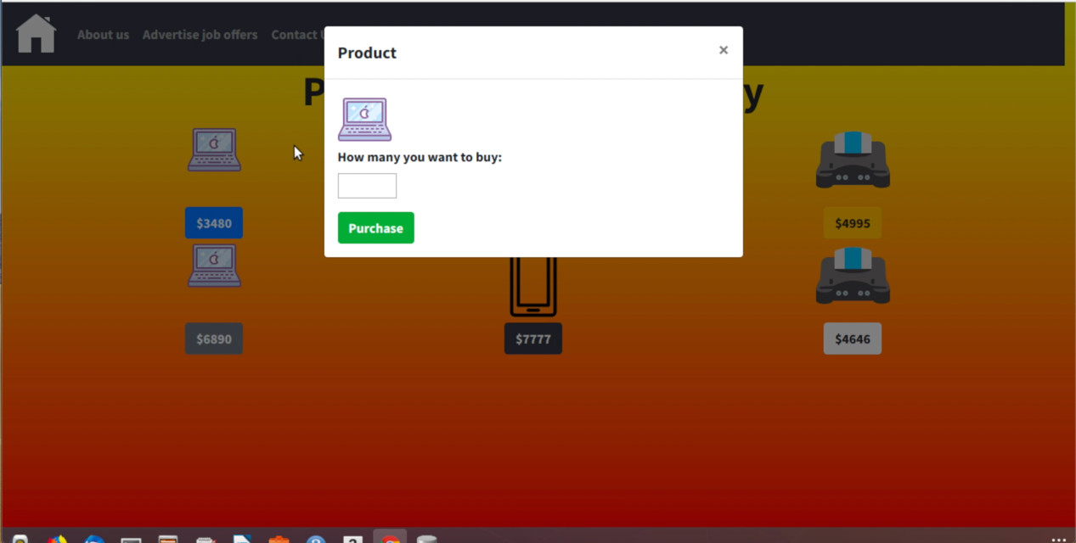

Return error

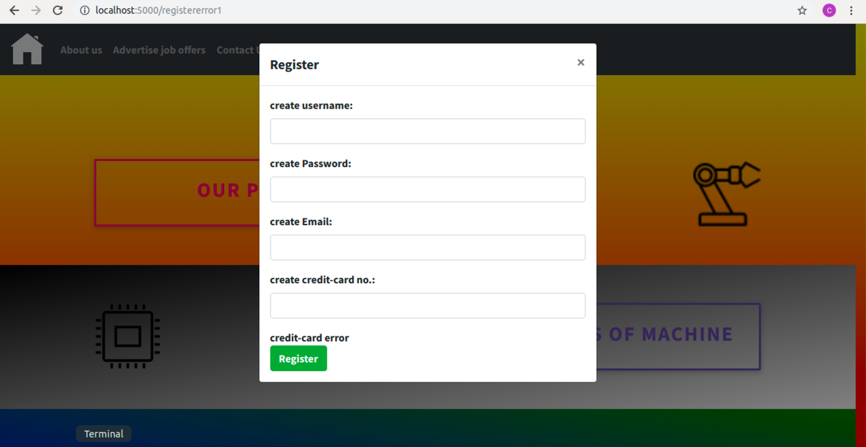

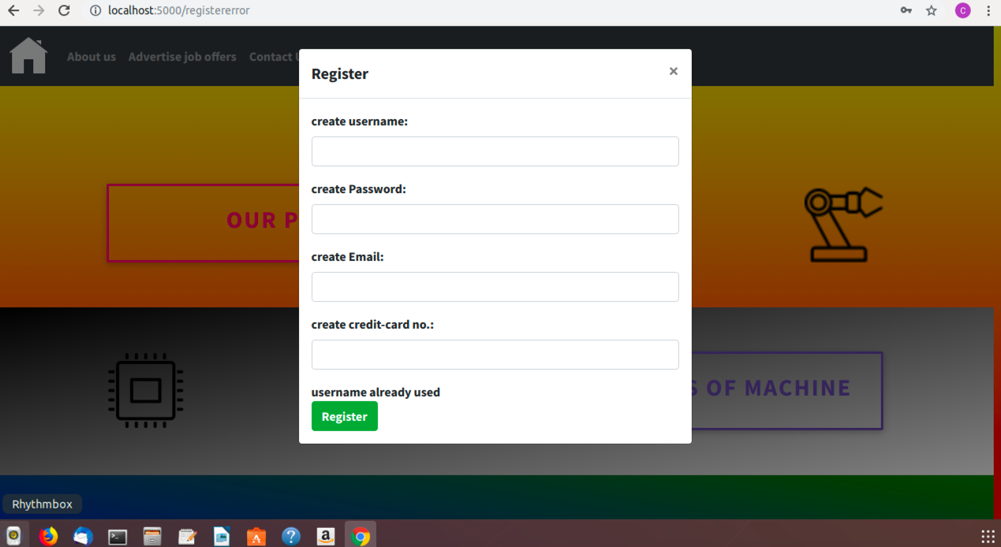

Upload sell request.

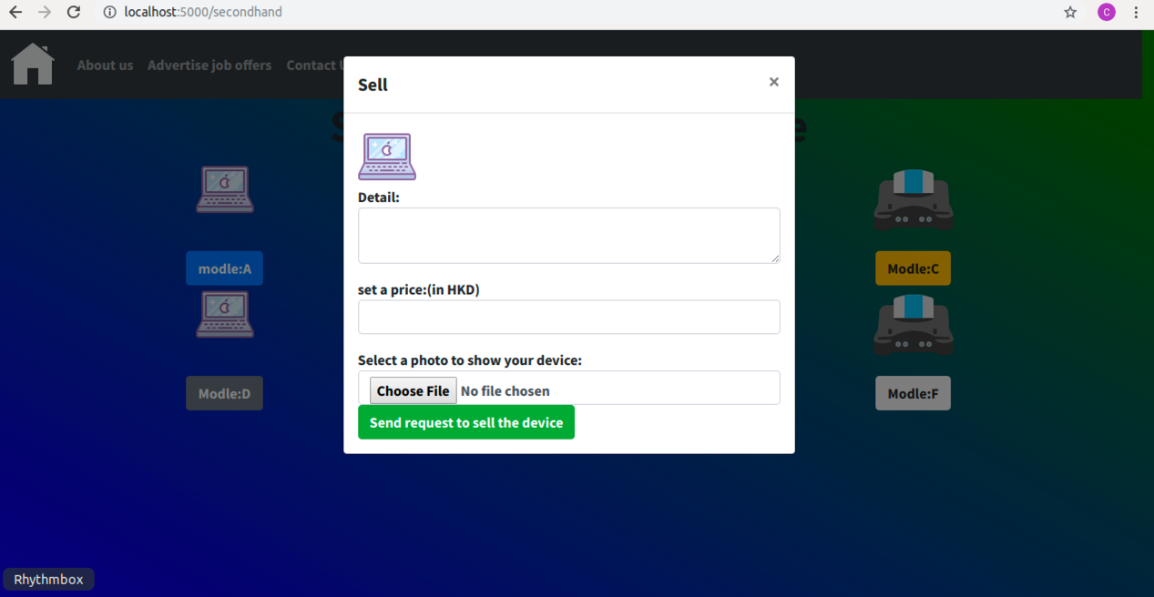

Purchase the component

